Intro
Today we will look at the overall lipid concentration of the average human diet.
While there are many opinions floating around about the safety of high levels of fat in our diet, the ketogenic diet has proven to be not only safe, but therapeutic in dealing with such things as epilepsy. In fact, The Epilepsy Foundation¹ offers this as a guideline:
- The typical "classical" ketogenic diet, called the "long-chain triglyceride diet," provides 3 to 4 grams of fat for every 1 gram of carbohydrate and protein. That is about 90% of calories from fat.
While our presentation today is not about the ketogenic diet, this diet does show that high fat diets, when managed, can be safe.
Our recommendation for a non-ketogenic, overall fat intake is that you should try to shoot for about 30 – 35% of your total energy intake from dietary lipids.
It’s important to note here that not all lipids are the same or provide the same effect.
Let’s take that total lipid intake and further divide it into an ideal intake, as well as how you can realistically incorporate this guideline into your diet.
Based on a 2000 calorie diet, we should have between 600 and 700 calories as a daily intake range for our total lipid consumption. Ideally, this should be broken down by the percentage of each major fatty acid type, keeping in mind that each group has its own unique members, with different and specific effects on our health and metabolism. Our recommendation is to aim for a total fat intake that consists of 30% saturated fatty acids, 40% monounsaturated fatty acids, and the remaining 30% of your dietary acid should be split between omega-3 and omega-6 polyunsaturated fatty acids.
So, let’s take a closer look at how we should distribute these calories among these types of fatty acids, thus providing an ideal fatty acid profile.

Saturated: 30% = 180 – 210 calorie per day
Now that we know that lipids are not created equal, we can start to take a closer look at saturated fat, a major subgroup of the lipid family that often makes people feel bad about fat.
SFAs are often correlated with various types of diseases, including cardiovascular diseases, metabolic disorders, and cancers (1-5). However, such statements depend on the specific context. For example, studies show that dietary SFA is not equal to the SFA level in human body (6-8). Unlike its role in human physiology, SFAs in dairy products are beneficial for overall health. Besides, compared with whole fat milk, low-fat milk did not show extra benefits in terms of cardiometabolic risk (9).
Various types of SFA function differently in the human body. Based on carbon chain length, there are mainly three types of SFA:
- SCFA (< 6 carbon atoms)
- MCFA ( 8-12 carbon atoms)
- LCFA (14-20 carbon atoms)
SCFAs are often produced via gut microbial fermentation (10, 11). MCFAs are enriched in coconut and dairy products, while LCFAs are often from animal and aquatic sources. The small physical size enables MCFAs to be directly absorbed and metabolized in liver. In contrast, LCFAs are absorbed through the lymphatic system, which helps LCFAs stay in the human body for quite a long period and potentially promotes pathophysiological processes like atherosclerosis (12). Such difference supports that MCFA is healthier than LCFA. Interestingly, in addition to fast metabolism, lauric acid as a type of MCFA also has been proved to have anti-inflammation and anti-infection effects (13, 14).
Every coin has two sides: the consumption of MCFA could lead to GI tract issues such as diarrhea, vomiting, and intestinal gas. Meanwhile, although almost all types of LCFAs were associated with disease progression, palmitic acid (C16) is the dominant bad guy while stearic acid (C18) plays a neutral/harmless role (15).
In a perfect world:
SFA intake should account for less than 10% of the total energy intake, in which the majority of SFAs should come from good/neutral SFAs like 3% caprylic (C8), 3% decanoic (C10), 2 % lauric (C12) and 2% stearic (C18).
In reality:
However, it is unrealistic to consume these SFAs individually from either natural or processed food. Instead, choosing the proper food source for SFAs deserves more attention. MCFA are enriched in coconut products like coconut oil (60%). Both dairy products and meat can serve as LCFA sources. Interestingly, the dairy SFA has been proved to be healthier than meat SFA in humans, although the exact mechanism is still vague (9).
Moreover, because other types of food could also contain SFAs, people are prone to overconsume SFAs in their meals, especially in the western diet. Therefore, the current dietary guidelines worldwide encourage SFA intake less than 10% of total calorie intake.
A diet plan customized for proper SFA intake probably looks like this: one tablespoon of coconut oil (14g, 120 Cal) + two cups of whole milk (474ml, 80 Cal)/a piece of 200-gram steak (11g,100 Cal), which easily hit the goal of daily intake of SFAs.

Mono: 40% = 240 – 280 calories per day (31-36g MUFA)
Currently, there is no precise guideline for how much of each monounsaturated fatty acid we should consume daily [17]. Monounsaturated fats are in a way considered as the leftover fats that can be incorporated into our diets. In addition, it seems that monounsaturated fatty acids must consider the incorporation of other fatty acids, like saturated and polyunsaturated, but also other metabolites like amino acids. Fatty acids are crucial for important functions in the body; however, the effects of many individual fatty acids are not well understood.
Just to give a brief introduction and explanation of what monounsaturated fatty acids are. Monounsaturated fatty acids (MUFAs) are classified as fatty acids that contain a single double bond in their chemical structure. The predominant form of monounsaturated fatty acids in food sources are the cis-isomers. This is where the hydrogen atoms are on the same side as the double bond.
Although there may be scarce information on each of the monounsaturated fats, here is some information that I have found from primary literature. A recent paper explained how myristoleic acid produced by enterococci reduces obesity through the activation of brown adipose tissue [18, 19]. Common sources of myristoleic acid are beef and cheddar cheese.
The carbon 16 MUFA, palmitoleic acid has been linked as an adipose tissue-derived lipid hormone that improves insulin sensitivity [20]. In a recent paper with an emphasis on heart health, palmitoleic acid showed to benefit in suppressing inflammation such as atherosclerosis in mice [21]. Some common sources of this fatty acid are macadamia nuts and oil [22].
The odd chained monounsaturated fatty acids such as pentadecenoic acid and heptadecenoic acid are rare in nature. However, some research has shown that they still play a role in human metabolism as intermediates, products, and even biological markers [23]. There was an early paper that expressed the heptadecenoic acid showed anti-inflammatory effects [24].
The most common fatty acid is oleic acid. It has been reported in showing neuroprotective effects in rodent models of cerebral ischemia [25]. In addition, oleic acid and its elongated fatty acid, nervonic acid, have shown importance in membrane structural lipids, particularly nervous tissue myelin [26].
Now we cannot forget about the longer chained fatty acids as they provide much benefit to our body. One interesting research paper studied the effects of long chained MUFAs and found that the gadoleic and erucic acid showed improvement in endothelial function with the alteration of the gut microbiota [27, 28]. Both fatty acids can be obtained from primarily fish such as cod fish and their oils.
In a perfect world:
Researchers would provide better guidelines for monounsaturated fatty acids. In addition, we would be able to consume the perfect fatty acid profile of each individual fatty acid. After analyzing many research papers and determining the importance of each monounsaturated fatty acid, a suggested guideline of MUFA intake would be from the more common and accessible fatty acids such as 4% palmitoleic acid (16:1), 24% oleic acid (18:1), 4% gadoleic acid (20:1), 4% erucic acid (22:1), and 4% nervonic acid (24:1).
In reality:
All MUFAs can be synthesized endogenously. We have all the enzymes required for the synthesis of monounsaturated fatty acids from acetyl-CoA [29]. Every SFA from C12:0 to C18:0 is converted to its respective monounsaturated product through the action of Δ9-desaturase (Stearoyl–CoA desaturase, SCD) but with varying efficiency [30].
There has been more research done with oleic acid because oleic acid accounts for about 92 percent of dietary monounsaturated fatty acids.
The most common source of MUFAs is olive oil.
- The major fatty acids in olive oil triacylglycerols are:
  - Oleic Acid (C18:1)
  - Some PUFAs (both omega-3 and omega-6)
  - Some saturated fats
- Very long chain monounsaturated fatty acids (C20 or greater) are not at appreciable amounts in olive oil. Therefore, we must get those fatty acids from other dietary sources.
In all, this information goes to show that monounsaturated fatty acids still maintain their reputation as healthy fats that have beneficial functions within the body. Therefore, monounsaturated fat can no longer be pushed aside as leftover fats, and they should be at the forefront in implementation for a healthier lifestyle.

N3 30%---split between n6 and n3 = 180 – 210 calories per day
When we talk about polyunsaturated fatty acids in our diet, we generally split them into 2 different categories based on their molecular structure: omega-3 and omega-6 fatty acids. These fatty acids are ‘competitively metabolized by the same set of desaturation, elongation, and oxygenase enzymes.’³¹ The lipid mediator products of these reactions perform antagonistically in the body, having an opposing functional role in ‘inflammation, platelet aggregation and vasoconstriction & dilation.’³¹
‘The parent fatty acid of the omega-6 series is linoleic acid (LA; 18:2n-6), and the parent fatty acid of the omega-3 series is α-linolenic acid (ALA; 18:3n-3).³²
Both n-3 and n-6 fatty acids belong to a small group of fatty acids, but nutritionally the ‘most important’³³ to humans, the essential fatty acids (EFAs). While humans do have enzymes to help interconvert these fatty acids into needed metabolites, they cannot be synthesized in the necessary amounts needed to preserve homeostasis in the host, and so must be obtained through the diet.
For the sake of dietary guidance, the current thinking is that these different families of lipid compounds should be consumed in balance with each other, since ‘overconsumption of n-6 PUFAs with low intake of n-3 PUFAs is highly associated with the pathogenesis of many modern diet-related chronic diseases.’³¹
In a perfect world:
We would consume these fatty acids in a 1:1 ratio
In reality:
We should aim to be in the range of 1:4³¹, with the bulk of this ratio being achieved though the diet.
One of the best sources for omega-3 fatty acids in the diet is from fish, such as wild caught salmon. It has been well recognized that:
‘global supply from all the traditional sources of these nutrients is insufficient to satisfy human nutritional requirements’³⁴
, thus farm raised sources of dietary fish are a viable option.
As consumers, we should know that there are some differences between these 2 sources, but this issue has been studied. As has been published³⁵, the farm raised fish tend to have a higher overall lipid content, so to ensure that they have adequate levels of PUFA in them, fish farmers must customize their dietary intakes via the composition of the fatty acids in their feed. Once this has been implemented, farm fish ‘can provide a similar or higher amount of n-3 PUFA'³⁵ to an equal sized potion of its wild caught counterparts.
While we see conflicting reports in the literature surrounding PUFA benefits, The American Heart Association recommends³⁶:
‘1 to 2 seafood meals per week be included to reduce the risk of congestive heart failure, coronary heart disease, ischemic stroke, and sudden cardiac death, especially when seafood replaces the intake of less healthy foods.’
based on the 2015–2020 Dietary Guidelines for Americans, and other factors such as sustainability.
Another option is using supplementation as a source of these essential fatty acids, but as is the case with any supplementation a review of the evidence found at such places as the Mayo Clinic³⁷, or the NIH³⁸, along with the consultation of a physician is always recommended to truly evaluate what course of action is best for each individual.
Additionally, it should be noted that like all the other lipids mentioned here, further research is needed to definitively understand the unique contribution of the different lipids based on the length of their carbon chain. An example of this is a recent paper³⁹ published showing that the PUFAs (both n3 and n6) stored in lipid droplets had different beneficial effects on tumors in an acidic environment, correlating to their carbon chain length, and number of double bonds, that was believed to be acting outside of the traditional role of eicosanoid production generally associated with PUFAs.

N6 30%---split between n6 and n3 = 180 – 210 calorie per day
In a perfect world:
We might want to consume more n-3 polysaturated fatty acid, as the toxicity of n-3 is quite limited. In the case of having a 1: 1 n-6/n-3 ratio, we could have 90-105 kcal n-6 daily.
In reality:
It’s not that easy to have 90-105 kcal n-3 polyunsaturated fatty acid from dietary food plus supplements, whereas it’s much easier to have n-6 in our diet. Linoleic acid is the most abundant n-6 fatty acid in dietary food, and it’s well distributed in oils. Linoleic acid is an essential fatty acid, which can be converted into other n-6 fatty acids like arachidonic acid. Arachidonic acid is the precursor of signaling factors, which is a component of cell membrane [40]. Based on the studies that have already been published [40-46], there’s no clear recommendation for daily arachidonic acid intake, and the reason is that there’s also no data supporting a specific amount of arachidonic acid needed every day. Too much arachidonic acid will be considered proinflammatory, but most food doesn’t contain much arachidonic acid. The effects of linoleic acid and arachidonic acid have been studied for decades, but the controversy still exists [41-43], especially for linoleic acid. Arachidonic acid is consistently recognized as harmful fatty acid [46], but linoleic acid has another story. Some recent study addresses that linoleic acid might be able to prevent cohort diseases [40], however the conversion to arachidonic acid is still a concern. One previous study shows that too much linoleic acid intake will increase the level of arachidonic acid which leads to inflammation [41]. Because of the abundance of linoleic acid in food [42], limiting its intake should be taken into consideration, and though arachidonic acid is thought to be proinflammatory, human body still needs it for cell membrane conformation and cell signaling, which means arachidonic acid should be included in n-6 fatty acids intake. According to the facts and studies listed above, 137-160kcal linoleic acid intake and 7-8kcal arachidonic acid intake might be considered reasonable. And in this case, the ratio of n-6/n-3 will be 4:1.
If we calculate the calories into dietary food, for example, 9.05 grams of corn oil contain about 160kcal linoleic acid, and 640 grams of chicken contain around 8kcal arachidonic acid, which fits the profile provided above.

Conclusion
So in review, while the perfect guidelines for dietary fat intake have yet to be made, we can use what we do know to say a few things:
First, we can say that in terms of normal human consumption, we should aim to have between 30 – 35% of our total caloric intake come from fats.
Second, we should remember that not all fats are the same and that we need to be mindful about the breakdown of our intake. We should aim to have 30% of our total fat intake be from saturated fats, 30% from polyunsaturated fats, and the remaining 40% should come from monounsaturated fats.
Third, we should dig a little deeper into each type of fatty acid, and try to locate better sources for each subtype of fatty acid. For example, in saturated fats the C18 is a better choice than the C16. That doesn’t mean we should avoid all C16 fatty acids, but instead we should remember the difference and make the best choice out of our available options. This is true for all the different families of fatty acids discussed here today.
This is illustrated in a recent animal study where the degree of saturation and the chain length of dietary triglycerides were examined for their effect on lipid profiles in serum and hepatic metabolism.⁴⁷ The researchers had these 3 things to say about their results:
First:
‘The results indicated that average chain length of the fatty acids of triglycerides has a higher influence on the quality of serum lipid parameters than the average degree of saturation.’
Next:
‘Expression of selected genes responsible for lipid metabolism showed similar trends in medium chain saturated and long chain polyunsaturated diet groups.’
Finally, they said that their:
‘study shows that the fats with medium chains and higher degree of saturation and fats with long chains and higher degree of unsaturation (lower degree of saturation) affect serum lipid parameters and expression of hepatic genes involved in the lipid metabolism in a similar manner.’

Going forward, it’s small changes such as being mindful about the differences in the profile of the fatty acids that we eat that will help lead to lasting, long term dietary success, and overall better health as a result.
Appendix
Since the perfect guidelines remain elusive, instead let’s look at some good sources for each type of dietary fat.

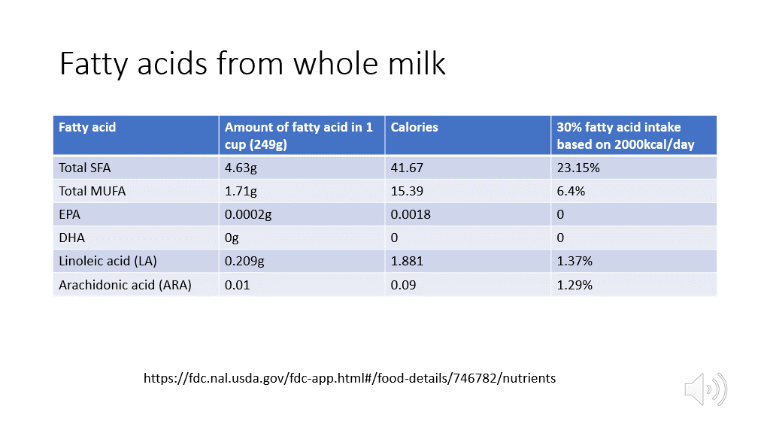
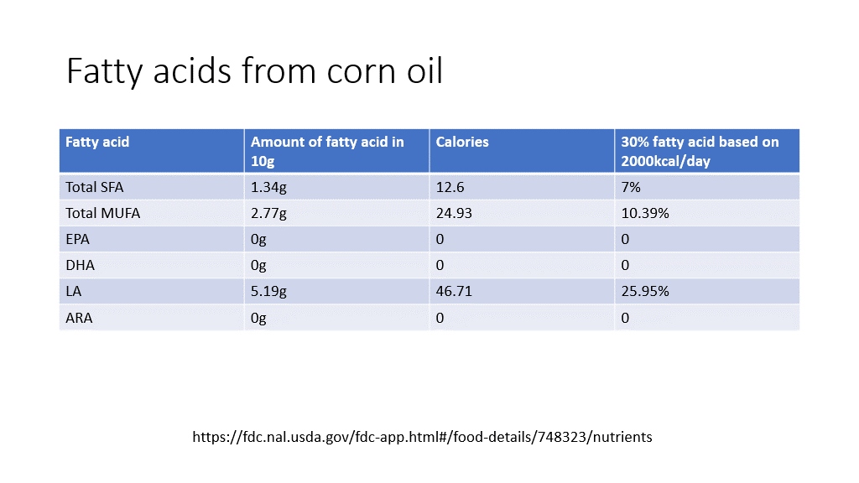

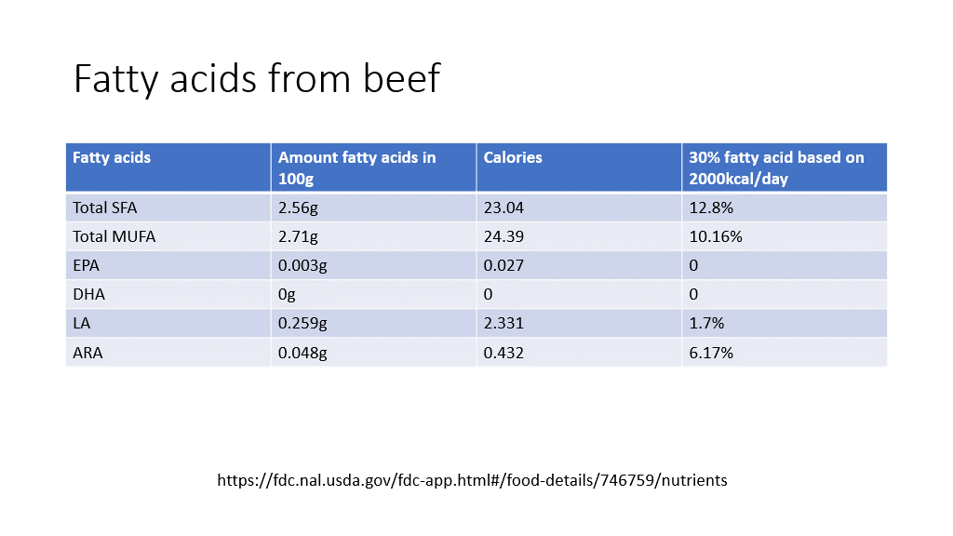

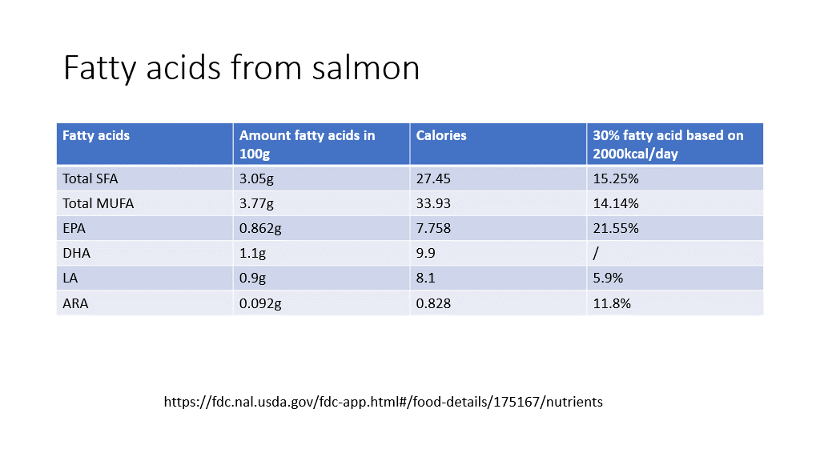

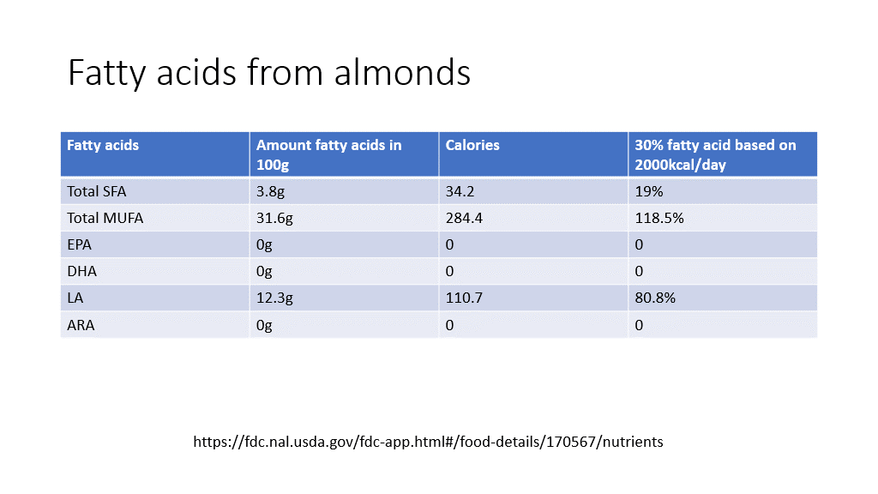

References:
1. Ketogenic Diet for Seizures | Epilepsy Foundation
2. Rocha, D. M., Caldas, A. P., Oliveira, L. L., Bressan, J., & Hermsdorff, H. H. (2016). Saturated fatty acids trigger TLR4-mediated inflammatory response. Atherosclerosis, 244, 211–215. https://doi.org/10.1016/j.atherosclerosis.2015.11.015
3. Ruiz-Núñez, B., Dijck-Brouwer, D. A., & Muskiet, F. A. (2016). The relation of saturated fatty acids with low-grade inflammation and cardiovascular disease. The Journal of nutritional biochemistry, 36, 1–20. https://doi.org/10.1016/j.jnutbio.2015.12.007
4. Leamy, A. K., Egnatchik, R. A., & Young, J. D. (2013). Molecular mechanisms and the role of saturated fatty acids in the progression of non-alcoholic fatty liver disease. Progress in lipid research, 52(1), 165–174. https://doi.org/10.1016/j.plipres.2012.10.004
5. Li, B., Leung, J., Chan, L., Yiu, W. H., & Tang, S. (2020). A global perspective on the crosstalk between saturated fatty acids and Toll-like receptor 4 in the etiology of inflammation and insulin resistance. Progress in lipid research, 77, 101020. https://doi.org/10.1016/j.plipres.2019.101020
6. Dierge, E., & Feron, O. (2019). Dealing with saturated and unsaturated fatty acid metabolism for anticancer therapy. Current opinion in clinical nutrition and metabolic care, 22(6), 427–433. https://doi.org/10.1097/MCO.0000000000000601
7. Ruiz-Núñez, B., Kuipers, R. S., Luxwolda, M. F., De Graaf, D. J., Breeuwsma, B. B., Dijck-Brouwer, D. A., & Muskiet, F. A. (2014). Saturated fatty acid (SFA) status and SFA intake exhibit different relations with serum total cholesterol and lipoprotein cholesterol: a mechanistic explanation centered around lifestyle-induced low-grade inflammation. The Journal of nutritional biochemistry, 25(3), 304–312. https://doi.org/10.1016/j.jnutbio.2013.11.004
8. Gaeini, Z., Mirmiran, P., Bahadoran, Z., Aghayan, M., & Azizi, F. (2021). The association between dietary fats and the incidence risk of cardiovascular outcomes: Tehran Lipid and Glucose Study. Nutrition & metabolism, 18(1), 96. https://doi.org/10.1186/s12986-021-00624-6
9. Nakamura, H., Tsujiguchi, H., Kambayashi, Y., Hara, A., Miyagi, S., Yamada, Y., Nguyen, T., Shimizu, Y., Hori, D., & Nakamura, H. (2019). Relationship between saturated fatty acid intake and hypertension and oxidative stress. Nutrition (Burbank, Los Angeles County, Calif.), 61, 8–15. https://doi.org/10.1016/j.nut.2018.10.020
10. Unger, A. L., Torres-Gonzalez, M., & Kraft, J. (2019). Dairy Fat Consumption and the Risk of Metabolic Syndrome: An Examination of the Saturated Fatty Acids in Dairy. Nutrients, 11(9), 2200. https://doi.org/10.3390/nu11092200
11. Blaak, E. E., Canfora, E. E., Theis, S., Frost, G., Groen, A. K., Mithieux, G., Nauta, A., Scott, K., Stahl, B., van Harsselaar, J., van Tol, R., Vaughan, E. E., & Verbeke, K. (2020). Short chain fatty acids in human gut and metabolic health. Beneficial microbes, 11(5), 411–455. https://doi.org/10.3920/BM2020.0057
12. Sanna, S., van Zuydam, N. R., Mahajan, A., Kurilshikov, A., Vich Vila, A., Võsa, U., Mujagic, Z., Masclee, A., Jonkers, D., Oosting, M., Joosten, L., Netea, M. G., Franke, L., Zhernakova, A., Fu, J., Wijmenga, C., & McCarthy, M. I. (2019). Causal relationships among the gut microbiome, short-chain fatty acids and metabolic diseases. Nature genetics, 51(4), 600–605. https://doi.org/10.1038/s41588-019-0350-x
13. Panth, N., Abbott, K. A., Dias, C. B., Wynne, K., & Garg, M. L. (2018). Differential effects of medium- and long-chain saturated fatty acids on blood lipid profile: a systematic review and meta-analysis. The American journal of clinical nutrition, 108(4), 675–687. https://doi.org/10.1093/ajcn/nqy167
14. Tham, Y. Y., Choo, Q. C., Muhammad, T., & Chew, C. H. (2020). Lauric acid alleviates insulin resistance by improving mitochondrial biogenesis in THP-1 macrophages. Molecular biology reports, 47(12), 9595–9607. https://doi.org/10.1007/s11033-020-06019-9
15. Xia, J., Yu, P., Zeng, Z., Ma, M., Zhang, G., Wan, D., Gong, D., Deng, S., & Wang, J. (2021). Lauric Triglyceride Ameliorates High-Fat-Diet-Induced Obesity in Rats by Reducing Lipogenesis and Increasing Lipolysis and β-Oxidation. Journal of agricultural and food chemistry, 69(32), 9157–9166. https://doi.org/10.1021/acs.jafc.0c07342
16. Hunter, J. E., Zhang, J., & Kris-Etherton, P. M. (2010). Cardiovascular disease risk of dietary stearic acid compared with trans, other saturated, and unsaturated fatty acids: a systematic review. The American journal of clinical nutrition, 91(1), 46–63. https://doi.org/10.3945/ajcn.2009.27661
17. Schwingshackl, L., & Hoffmann, G. (2012). Monounsaturated fatty acids and risk of cardiovascular disease: synopsis of the evidence available from systematic reviews and meta-analyses. Nutrients, 4(12), 1989–2007. https://doi.org/10.3390/nu4121989
18. Quan, L. H., Zhang, C., Dong, M., Jiang, J., Xu, H., Yan, C., Liu, X., Zhou, H., Zhang, H., Chen, L., Zhong, F. L., Luo, Z. B., Lam, S. M., Shui, G., Li, D., & Jin, W. (2020). Myristoleic acid produced by enterococci reduces obesity through brown adipose tissue activation. Gut, 69(7), 1239–1247. https://doi.org/10.1136/gutjnl-2019-319114
19. Choi, Y. K., Kang, J. I., Hyun, J. W., Koh, Y. S., Kang, J. H., Hyun, C. G., Yoon, K. S., Lee, K. S., Lee, C. M., Kim, T. Y., Yoo, E. S., & Kang, H. K. (2021). Myristoleic Acid Promotes Anagen Signaling by Autophagy through Activating Wnt/β-Catenin and ERK Pathways in Dermal Papilla Cells. Biomolecules & therapeutics, 29(2), 211–219. https://doi.org/10.406/biomolther.2020.169
20. Cao H, et al. Identification of a lipokine, a lipid hormone linking adipose tissue to systemic metabolism. Cell. 2008;134:933–944. doi: 10.1016/j.cell.2008.07.048
21. Çimen I, et al. Prevention of atherosclerosis by bioactive palmitoleate through suppression of organelle stress and inflammasome activation. Sci. Transl. Med. 2016;8:358. doi: 10.1126/scitranslmed.aaf9087
22. Ghulam Kadir Ahmad Parveez, Omar A. Rasid, Ahmad Tarmizi Hashim, Zamzuri Ishak, Samsul Kamal Rosli, Ravigadevi Sambanthamurthi, 4 - Tissue Culture and Genetic Engineering of Oil Palm, Palm Oil, AOCS Press, 2012, Pages 87-135, ISBN 9780981893693, https://doi.org/10.1016/B978-0-9818936-9-3.50007-1
23. Team, E., 2022. cis-10-pentadecenoic acid (CHEBI:75089). [online] Ebi.ac.uk. Available at: <https://www.ebi.ac.uk/chebi/searchId.do?chebiId=CHEBI:75089> [Accessed 16 April 2022].
24. Degwert, J., Jacob, J., & Steckel, F. (1998). U.S. Patent No. 5,708,028. Washington, DC: U.S. Patent and Trademark Office.
25. Song, J., Kim, Y. S., Lee, D. H., Lee, S. H., Park, H. J., Lee, D., & Kim, H. (2019). Neuroprotective effects of oleic acid in rodent models of cerebral ischaemia. Scientific reports, 9(1), 10732. https://doi.org/10.1038/s41598-019-47057-z
26. Lewkowicz, N., Piątek, P., Namiecińska, M., Domowicz, M., Bonikowski, R., Szemraj, J., Przygodzka, P., Stasiołek, M., & Lewkowicz, P. (2019). Naturally Occurring Nervonic Acid Ester Improves Myelin Synthesis by Human Oligodendrocytes. Cells, 8(8), 786. https://doi.org/10.3390/cells8080786
27. Tsutsumi, R., Yamasaki, Y., Takeo, J., Miyahara, H., Sebe, M., Bando, M., Tanba, Y., Mishima, Y., Takeji, K., Ueshima, N., Kuroda, M., Masumoto, S., Harada, N., Fukuda, D., Yoshimoto, R., Tsutsumi, Y. M., Aihara, K. I., Sata, M., & Sakaue, H. (2021). Long-chain monounsaturated fatty acids improve endothelial function with altering microbial flora. Translational research: the journal of laboratory and clinical medicine, 237, 16–30. https://doi.org/10.1016/j.trsl.2021.03.016
28. Kim, E., Ko, H. J., Jeon, S. J., Lee, S., Lee, H. E., Kim, H. N., Woo, E. R., & Ryu, J. H. (2016). The memory-enhancing effect of erucic acid on scopolamine-induced cognitive impairment in mice. Pharmacology, biochemistry, and behavior, 142, 85–90. https://doi.org/10.1016/j.pbb.2016.01.006
29. Landry, F., Chan, C. C., Huang, Z., Leclair, G., Li, C. S., Oballa, R., Zhang, L., & Bateman, K. (2011). Plasma-based approach to measure target engagement for liver-targeting stearoyl-CoA desaturase 1 inhibitors. Journal of lipid research, 52(8), 1494–1499. https://doi.org/10.1194/jlr.M013177
30. Legrand, P., & Rioux, V. (2010). The complex and important cellular and metabolic functions of saturated fatty acids. Lipids, 45(10), 941–946. https://doi.org/10.1007/s11745-010-3444-x
31. Mariamenatu AH, Abdu EM. Overconsumption of Omega-6 Polyunsaturated Fatty Acids (PUFAs) versus Deficiency of Omega-3 PUFAs in Modern-Day Diets: The Disturbing Factor for Their "Balanced Antagonistic Metabolic Functions" in the Human Body. J Lipids. 2021 Mar 17;2021:8848161. doi: 10.1155/2021/8848161. PMID: 33815845; PMCID: PMC7990530.
32. https://lpi.oregonstate.edu/mic/other-nutrients/essential-fatty-acids#introduction
33. Cholewski M, Tomczykowa M, Tomczyk M. A Comprehensive Review of Chemistry, Sources and Bioavailability of Omega-3 Fatty Acids. Nutrients. 2018 Nov 4;10(11):1662. doi: 10.3390/nu10111662. PMID: 30400360; PMCID: PMC6267444
34. Tocher DR, Betancor MB, Sprague M, Olsen RE, Napier JA. Omega-3 Long-Chain Polyunsaturated Fatty Acids, EPA and DHA: Bridging the Gap between Supply and Demand. Nutrients. 2019 Jan 4;11(1):89. doi: 10.3390/nu11010089. PMID: 30621155; PMCID: PMC6356973.
35. M.A. Hossain, . Fish as Source of n-3 Polyunsaturated Fatty Acids (PUFAs), Which One is Better-Farmed or Wild?. Advance Journal of Food Science and Technology, (6): 455-466.
36. Rimm EB, Appel LJ, Chiuve SE, Djoussé L, Engler MB, Kris-Etherton PM, Mozaffarian D, Siscovick DS, Lichtenstein AH; American Heart Association Nutrition Committee of the Council on Lifestyle and Cardiometabolic Health; Council on Epidemiology and Prevention; Council on Cardiovascular Disease in the Young; Council on Cardiovascular and Stroke Nursing; and Council on Clinical Cardiology. Seafood Long-Chain n-3 Polyunsaturated Fatty Acids and Cardiovascular Disease: A Science Advisory From the American Heart Association. Circulation. 2018 Jul 3;138(1):e35-e47. doi: 10.1161/CIR.0000000000000574. Epub 2018 May 17. PMID: 29773586; PMCID: PMC6903778.
37. Fish oil - Mayo Clinic
38. Omega-3 Supplements: In Depth | NCCIH (nih.gov)
39. Dierge E, Debock E, Guilbaud C, Corbet C, Mignolet E, Mignard L, Bastien E, Dessy C, Larondelle Y, Feron O. Peroxidation of n-3 and n-6 polyunsaturated fatty acids in the acidic tumor environment leads to ferroptosis-mediated anticancer effects. Cell Metab. 2021 Aug 3;33(8):1701-1715.e5. doi: 10.1016/j.cmet.2021.05.016. Epub 2021 Jun 11. PMID: 34118189.
40. Christopher E Ramsden, Daisy Zamora, Boonseng Leelarthaepin, Sharon F Majchrzak-Hong, Keturah R Faurot, Chirayath M Suchindran, Amit Ringel, John M Davis, Joseph R Hibbeln. Use of dietary linoleic acid for secondary prevention of coronary heart disease and death: evaluation of recovered data from the Sydney Diet Heart Study and updated meta-analysis. BMJ. 2013 Feb 4; 346:e8707.
41. Dong D. Wang. Dietary n-6 polyunsaturated fatty acids and cardiovascular disease: Epidemiologic evidence. Prostaglandins, Leukotrienes and Essential Fatty Acids 135 (2018) 5–9.
42. Se´bastien Czernichow, Daniel Thomas and Eric Bruckert. n-6 Fatty acids and cardiovascular health: a review of the evidence for dietary intake recommendations. British Journal of Nutrition (2010), 104, 788–796.
43. Jessie L. Burnsa, Manabu T. Nakamurab, David W.L. Maa. Differentiating the biological effects of linoleic acid from arachidonic acid in health and disease. Prostaglandins, Leukotrienes and Essential Fatty Acids 135 (2018) 1–4.
44. Eric S. Williams, M.D., Ana Baylin, Dr.P.H., M.D., and Hannia Campos, Ph.D. Adipose Tissue Arachidonic Acid and the Metabolic Syndrome in Costa Rican Adults. Clin Nutr. 2007 August; 26(4): 474–482.
45. Jacqueline K. Innesa, Philip C. Calder. Omega-6 fatty acids and inflammation. Prostaglandins, Leukotrienes and Essential Fatty Acids 132 (2018) 41–48.
46. Kevin C Maki, Fulya Eren, Martha E Cassens,2Mary R Dicklin, and Michael H Davidson. ω-6 Polyunsaturated Fatty Acids and Cardiometabolic Health: Current Evidence, Controversies, and Research Gaps. Adv Nutr 2018; 9:688–700.
47. Senanayake CM, Hapugaswatta H, Samarawickrama GR, Jayathilaka N, Seneviratne KN. Effect of chain length and saturation of the fatty acids in dietary triglycerides on lipid metabolism in Wistar rats. J Food Biochem. 2021 Apr;45(4):e13664. doi: 10.1111/jfbc.13664. Epub 2021 Feb 18. PMID: 33598998.

